Smart Seat

Project Plan V0.9

**Group members：**Hanyu Zhang, Tinghui Zhang, Huiying Han, Yikang Tao

**Directory**

Smart Seat 1

1 Introduction 4

1.1 The purpose of writing 4

1.2 Background 4

1.3 Define 4

1.4 Reference 5

1.5 Standards、conditions and conventions 5

2. Description of project 6

2.1 Project target 6

2.2 Project objectives and scope 6

2.3 Assumptions and constraints 6

2.4 Scope of project work 7

2.5 Deliverables 7

2.5.1 Products to be completed 7

2.5.2 The user’s documentation needs to be submitted 7

2.5.3 Internal documents need to be submitted 7

2.5.4 Services to be provided 8

2.6 Project development environment 8

2.7 Method and basis of project acceptance 8

2.7.1 Acceptance of code 8

2.7.2 Acceptance of documents 8

2.7.3 Acceptance of services 9

3 Project team organization 10

3.1 The structure of the organization 10

3.2 Personnel division of labor 10

3.3 Collaboration and communication 11

4 Carry out the plan 12

4.1 Risk assessment and countermeasures 12

4.2 Overall schedule 12

5 The budget 13

5.1 The cost of equipment 13

5.2 Personnel costs 13

5.3 Other budget 13

# 1 Introduction

## 1.1 The purpose of writing

If you want to successfully complete the development of a software project, you must first have a unified plan, in which all the project participants need to clarify their responsibilities, ensure the orderly collaboration between the project team, so that all the processes in the project can be carried out in a reasonable and orderly way. At the same time, the plan can also play a guiding role in the communication within and outside the team, the scope of work between the teams, the relationship between development modules, and the development schedule, budget, allocation of human and material resources, risks and other factors are described roughly.

This project plan is mainly used to guide the smooth progress of the "smart seat" project and ultimately design the approved project products. The project plan is open to all members of the project team.

## 1.2 Background

At present, there are many seats in university libraries, but there are still a large number of seats in short supply in the peak period of use, and occasionally some students are unhappy because of the seat occupying behavior. Many students in the library after a long time search, still did not find a place to learn to read, delayed a lot of time, which greatly reduced the students' enthusiasm for learning.

The current library equipment is perfect, but the repair is not timely, although there is often a location, but because of the damage of the hardware facilities as a result of the normal use of the situation.

## 1.3 Define

Technical terms:

**MySQL:** database relational system (DBMS) used by the system server.

**SQL:** a language for accessing query databases

**Transaction flow:** data may be processed in multiple paths once it enters the module.

**SQL:** Structured Query Language.

**UML:** unified modeling language (UML) is a set of standard modeling language to design software blueprints. It is a standardized modeling language from software analysis, design to programming specifications.

## 1.4 Reference

《Software project management》Rajeev T Shandilya Science press

《UML and pattern applications》Craig Larman Machinery industry press

National standards document for software engineering

## 1.5 Standards、conditions and conventions

The project follows the following standards:

**GB/T** computer software classification and code

**GB/T** information technology

**GB/T** software engineering

**GB/T** software engineering standard taxonomy

**GB/T** computer test documentation

**GB/T** computer software requirements specification

**GB/T** computer software testing specifications

**GB/T** information technology programming language

**GB/T** information technology software engineering

**GB/T** computer software documentation specifications

## 1.6 WBS

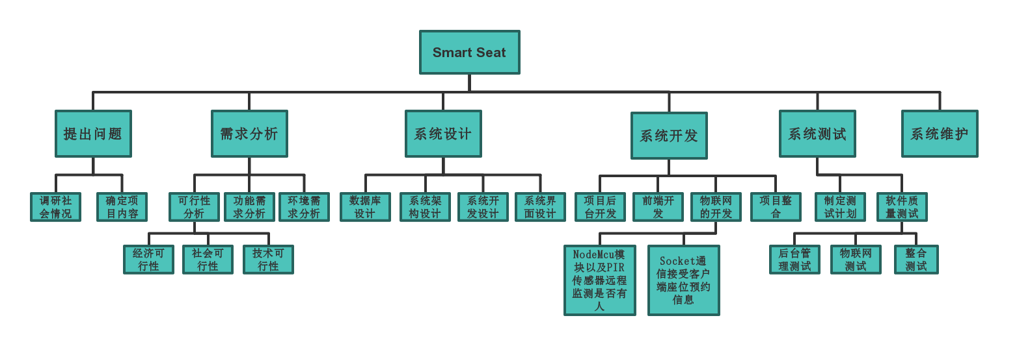

# 2. Description of project

## 2.1 Project target

* Design a smart seat occupying system sample based on the Internet of things
* Developed can be put into use of the intelligent seat background management system

## 2.2 Project objectives and scope

Smart Seat will eventually realize intelligent Seat system through the web system view the current state of the library's Seat (free, taking up, busy), if the Seat is in the idle state library, can Seat reservation, if Seat after a period of time after the scheduled nobody manually to Seat the system will automatically release the Seat to idle state; If the seat is in the scheduled valid time, the sensor senses that there is someone at the seat, but no one manually confirms the arrival of the seat, a warning message will be sent to the administrator, who will intervene. Students can also apply for repair information of seats through the system.

The system can also automatically statistics seat occupied time, and statistical data display to the background.

The design goal of this product is to improve the utilization rate of students' time and library seats, mobilize students' learning enthusiasm, and better maintain the order of library seats. At the same time, it can also ensure the library seat management and information statistics.

## 2.3 Assumptions and constraints

Factors for these assumptions may include:

* Assume that the user is not satisfied with the functionality of the product
* Assume the user doesn't understand how the product works
* Assume that there is a conflict between software users and non-software users
* A software development module was not delivered on time
* Finally, when the integration occurs, there is a conflict and the integration cannot be completed
* The software is not well adapted to various operating environments and platforms

These constraints may include:

* The constraint must deliver the final product by May 14, 2019
* Constraint equipment budget ￥300

## 2.4 Scope of project work

The design of the product aims at the problem of difficult to occupy a seat in the library, and combines the emerging technology of the Internet of things, mainly through the combination of software and hardware. The target is all the teachers and students in the school. The system is mainly used to help users of the system to realize the function of automatic seat occupied, but also to help the library to realize timely understanding of the damage of seats.

## 2.5 Deliverables

### 2.5.1 Products to be completed

* Smart seat occupying system sample based on Internet of things
* Intelligent seat occupying system background management system

### 2.5.2 The user’s documentation needs to be submitted

* User operation manual: this manual describes the function, performance and user interface of the software in detail, so that users can get a specific understanding of how to use the software, and provide operators with relevant knowledge of various running conditions of the software, especially the specific details of operation methods.
* Software maintenance manual: it mainly includes software system description, program module description, operating environment, supporting software description and maintenance process description to facilitate software maintenance.

### 2.5.3 Internal documents need to be submitted

* Feasibility analysis report
* Project development plan
* Software requirements statement
* Summary design specification
* Detailed design specification
* The test plan
* Test analysis report
* Development progress report
* Project development summary report
* Software problem report
* Software modification report
* Source program

### 2.5.4 Services to be provided

The following services are planned:

* Video tutorial: to train users in the form of video so that they can use the product correctly.
* Free consultation: users can ask questions and get answers from technicians during working hours.
* Technical support: for some users can provide door-to-door technical support services.
* Software maintenance: to obtain software problems in use and provide free update patches.

## 2.6 Project development environment

Support conditions needed during development:

Hardware:

* Server: Pentium III above 500 or higher
* RAM：over 128M
* ROM：at least 10G above

Software:

* The operating system is Windows 8 or above, and the integrated development tools Arduino IDE and PyCharm are used. MySQL is used as the database, and the project running environment is apache2.4.

## 2.7 Method and basis of project acceptance

### 2.7.1 Acceptance of code

Finally, the code shall be reviewed within the project team before delivery. The code shall be written in accordance with the HB6465 standard and the document description. The code shall be written in the same style and standard specification.

### 2.7.2 Acceptance of documents

Finally, the project team shall review the document before delivery. The document format conforms to the HB6465 standard, and the function conforms to the requirements of the project plan and requirement specification. The document shall be clear and easy to understand, without any language errors or ambiguity.

### 2.7.3 Acceptance of services

The service hardware meets the requirements of the documentation, the personnel and technical assessment is qualified, and the project is maintained and updated regularly.

# 3 Project team organization

## 3.1 The structure of the organization

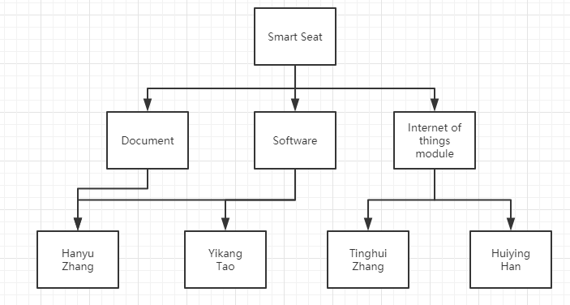

## 3.2 Personnel division of labor

|  |  |  |
| --- | --- | --- |
| Name | Role | Description of work |
| Hanyu Zhang | Project management, preliminary analysis, design, testing | Analyze system requirements, project plan, project team management, check progress, Git branch management and functional module testing and integration |
| Tinghui Zhang | Analysis, the design of the Internet of things module | Analyze the new function, use NodeMcu module and PIR sensor to realize the function of remote monitoring whether the seat is occupied |
| Huiying Han | the design of the Internet of things module | Socket communication is used to receive the seat reservation information of the client, and the indicator light on the seat is remotely controlled by sending instructions to realize the function of seat reservation |
| Yikang Tao | Background management system design, coding | Software framework construction, code module design, database design, project background design and coding |

## 3.3 Collaboration and communication

The waterfall model was adopted for development. Everyone within the team had their own design module, and finally module integration was carried out.

The project team adopts the communication method of meeting every week, 1-2 times, and each time is recorded as a weekly report. The weekly report includes: participants, everyone's project progress, current problems, proposed solutions, plans for the next stage, etc.

# 4 Carry out the plan

## 4.1 Risk assessment and countermeasures

* There is no consensus among developers

All functions should be discussed in meetings before formal development. All problems should be discussed in place. If no agreement is reached, the development should not be carried out until the communication is unified.

* Developers procrastinate

We still need to have a good communication to see where we are not satisfied so we do not cooperate. As for the delayed progress, the corresponding developers should take remedial measures and accept corresponding punishment.

* Tool failure

Replace tools when problems are found.

* The software cannot be completed on schedule

Different engineering stages require different personnel, who can be flexible within the scope of capacity, and work closely with each other to ensure effective software management.

* There is not enough technology available to meet performance requirements

However, the current software developers are not familiar with the current technology, so they should take this issue into consideration and make reasonable tradeoffs when making software development plans and defining milestones.

## 4.2 Overall schedule

# 5 The budget

## 5.1 The cost of equipment

|  |  |  |
| --- | --- | --- |
| Name | Count | Price |
| Nodemcu | 1 | ￥25 |
| PIR | 1 | ￥6 |
| Diode | 1 | ￥20 |

## 5.2 Personnel costs

No developer costs.

## 5.3 Other budget

Project weekly meeting will produce partial defray, specific and according to the circumstance to decide.